**Sample plots of phytoplankton**

Regions labeled Phyto1 (Red) and Phyto2 (Blue) are possibly eukaryotes that are relatively lower in phycocyanin compared to other regions based on Red-R fluorescence, and large size based on the forward scatter plot, with Phyto2 larger than Phyto1.

PC-Cyano consists of cells that are possibly cyanobacteria with high phycocyanin based on the relatively high Red-R fluorescence, with PC1 (Cyan), P2 (Light Green), and PC3 (Dark Green) as the subpopulations of the PC-Cyano region. The region labeled PC3 is possibly a M*icrocystis*-like region, and has the highest in phycocyanin within the PC-Cyano region based on the Red-R vs. Red-B plot. It should also be noted that the region is relatively high in phycoerythrin levels based on the Yellow-B vs. Red-B plot. This cluster is relatively large based on the forward scatter. This could be due to *Microcystis* colony formation. The regions labeled as PC1 and PC2 are likely to be *Synechococcus*-like cells, with PC1 being smaller in size, and PC2 being large possibly due to clustering.

**Sample plot of bacterioplankton**

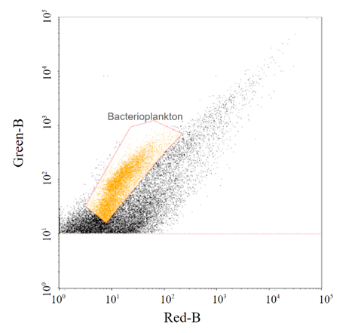

The region from the Green-B vs. Red-B plot was selected to identify populations that are bacterioplankton, which distinguishes from the abiotic particles.